**PillTrack: *IoT for medication management***

**Desirée Constantino de Almeida Barboza**

*desiree.barbosa@etec.sp.gov.br*

**Giovana Marsigli Rodrigues**

*giovana.rodrigues48@etec.sp.gov.br*

**Isabelle Gomes de Souza Andrade**

*isabelle.andrade9@etec.sp.gov.br*

|  |  |
| --- | --- |
| **Keywords:**  *Management.*  *Medication.*  *IoT.*  *App.*  **Palabras clave:**  *Gestión.*  *Medicatión.*  *IoT.*  *Aplicatión.*  **Presented on**  December, 05th, 2024  **Event:**  7º EnGeTec  **Event Local:**  Fatec Zona Leste  **Evaluators:**  Avaliador 1  Avaliador 2  [Desenho com traços pretos em fundo branco e letras pretas em fundo branco  Descrição gerada automaticamente com confiança média](https://creativecommons.org/licenses/by-nc-sa/4.0/) | **Abstract:**  The project addresses creating an efficient medication management system to ensure treatment adherence and improve patients' health outcomes, especially for the elderly. The system will include an intelligent medication box for notifications of administration times and stock control and a mobile app for recording and accessing information about patients' medication routines, doctors, and caregivers. The methodology will involve implementing and testing the system in a controlled environment, followed by qualitative user experience evaluation and quantitative analysis of treatment adherence data and health outcomes. The system is expected to significantly improve users' quality of life by boosting health outcomes, with benefits such as better adherence to drug treatment, reduced medication administration errors, and improved patients' health indicators. In conclusion, the study will highlight the effectiveness of the technological approach adopted in managing medicines and its benefits for public health, underlining the importance of innovative solutions in the care of chronic patients, especially the elderly.  **Resumen:**  El proyecto pretende crear un sistema completo y eficiente de gestión de la medicación para garantizar el cumplimiento del tratamiento y mejorar los resultados sanitarios de los pacientes, especialmente los ancianos. El sistema incluirá un botiquín inteligente para notificar los tiempos de administración y controlar las existencias, así como una aplicación móvil para que médicos y cuidadores registren y accedan a la información sobre la rutina de medicación de los pacientes. La metodología consistirá en implantar y probar el sistema en un entorno controlado, seguido de una evaluación cualitativa de la experiencia del usuario y un análisis cuantitativo de los datos de cumplimiento del tratamiento y los resultados sanitarios. Se espera que el sistema mejore significativamente la calidad de vida de los usuarios al potenciar los resultados sanitarios, con beneficios como una mejor adherencia al tratamiento farmacológico, una reducción de los errores en la administración de medicamentos y una mejora de los indicadores de salud de los pacientes. En conclusión, el estudio pondrá de relieve la eficacia del enfoque tecnológico adoptado en la gestión de medicamentos y sus beneficios para la salud pública, destacando la importancia de las soluciones innovadoras en la atención a los pacientes crónicos, especialmente los ancianos. |

1. **Introduction**

According to Eurofarma (2018), following the doctor's prescription at the correct times is crucial, regardless of age. The doctor adapts the treatment based on the individual's body, considering their habits and routines. Considering this, this project focuses on the seriousness of medication management by making a proposed technological solution to organize and monitor the proper treatment of each medication for the user.

This study is justified by the importance of ensuring correct adherence to medication use, considering the challenges patients face in following prescriptions at the proper times. Technology has the potential to minimize forgetfulness and improve medication management, making it a relevant solution for optimizing treatments and reducing complications arising from poor medication administration. In this way, technology is evolving to meet society's needs, keeping pace with its evolution. This led us to the emergence of the Internet of Things (IoT), which has great potential (ALBERTIN, 2017).

Today, the Internet of Things is rapidly becoming a reality, as we can see by looking around that our devices are getting smarter every day (SANTOS, 2018). With this technology, it is possible to automate time-consuming or forgotten tasks. In healthcare, an IoT system becomes a valuable tool for patients and professionals, improving the understanding and management of activities.

The problem revolves around the difficulty that many patients, especially the elderly, have in strictly following prescribed treatments, either through forgetfulness or lack of discipline, which compromises the effectiveness of medicines and can aggravate health conditions. Combined with medical knowledge, an IOT can act in preventive medicine, improving quality of life and patient satisfaction (MASSOLA; PINTO, 2018). According to data referenced by the Cardiology Society of the State of São Paulo (KATZ; FEITOSA; PINTO; FELIX, BORTOLOTTO, 2020), “it is estimated that half of the 3.2 billion medical prescriptions made annually in the USA are not followed correctly”. In this way, creating an assistive system makes a big difference in recovery and prevents forgetfulness, which causes the worsening of conditions that require treatment.

Thus, the system can significantly improve medication adherence. With easy access to medication information and automatic notifications, users are encouraged to follow medical guidelines, reducing forgetfulness and increasing the long-term effectiveness of treatments.

Access to the system allows for a more specific analysis by caregivers and doctors of patients' adherence to treatment, and in the case of elderly patients, who are more likely to forget doses and schedules, the creation of the application becomes even more optimistic, since it tends to solve these problems, contributing to improving the quality of care, ensuring the correct administration of medicines, thus making the project unique and innovative with automation in the problem addressed.

In this article, we will use React Native (FACEBOOK, 2015) to develop the application, Firebase (GOOGLE, 2014) to store the data, C++ to build the system's programming (STROUSTRUP, 1985), and UML 2 (GUEDES, 2018) to document the project's diagrams.

1. **Fundamentação Teórica**

This chapter covers the main theories, concepts, and technologies used to develop the PillTrack project.

* 1. **Difficulties ineffective medicines management**

One of the fundamental principles for good recovery and treatment is direct communication between patients and doctors, allowing them to achieve the best results together in the fight against disease. Short consultation times and poor communication increase the propensity for distancing and hyper-formality in dialog, contributing to these problems (PIXEL DIAGNÓSTICO, 2020). In other words, a detailed medical history can act as a map to prevent future health problems (UNIMED CAMPINAS).

In this way, resources that facilitate this monitoring can be used, and doctors can rely on *software* technologies to manage patient information in one place. They will have more time to monitor their patients.

A survey carried out by students at the University of São Paulo (USP) with health professionals and the reactions most often cited by professionals included terms such as "serious," "worsening," "worry," "harmful," and "death," reflecting the effects of poor adherence to treatment for both patients and professionals (FERREIRA; CAMPOS, 2023).

This is why the PillTrack application was conceived, which, as well as helping patients to take their medication correctly according to their doctor's prescription, will also enable direct interaction between doctor and patient through detailed reports made available by the application, which will have access to information straight out of the box. To understand how the PillTrack project will work, keep reading; our system will be more detailed in the following chapters.

* 1. **PillTrack: IoT for medicines management**

PillTrack has been designed to help with the effectiveness and management of medication, especially for those who are elderly and find it difficult to take their medication correctly according to the prescription because they take too much medication or because their memory fails.

It consists of a 3D machine-printed smart medicine box that notifies the patient when they need to take their medication, monitors the stock of pills, and records information about the medication routine so that doctors and caregivers can be sure that the patient is following the prescription correctly.

The box uses the ESP32 microcontroller that connects to the application via *Wi-Fi*, guaranteeing real-time updates. Therefore, the PillTrack innovative medicine box has come to facilitate treatment adherence, reducing failures in the medication routine, especially for those who are elderly and need special attention and tend to have a routine with multiple prescriptions daily.

The 3D modeling of PillTrack is shown below:

Figure 1 - PillTrack 3D modeling

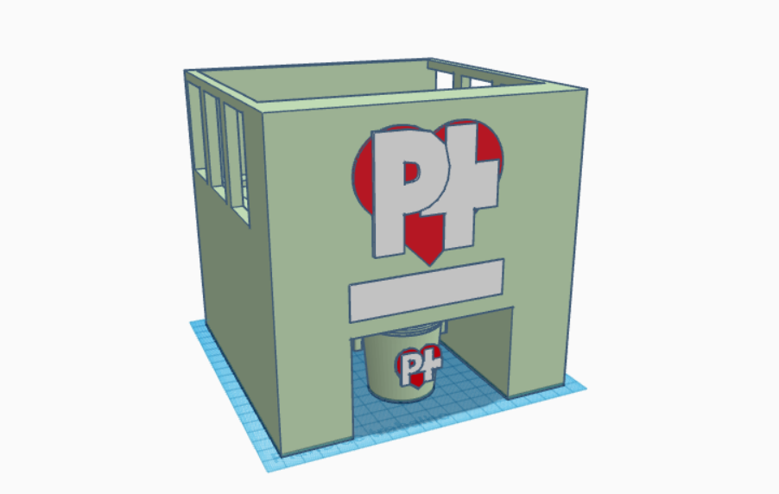

Source: From the authors (2024).

As you can see in the image, we have a 3D modeling prototype designed to make it easier to keep track of medication schedules. On the sides of the boxes, entrances have been designed for inserting the medication. On the front, there is a space for the LCD, which will show the time, the name of the box, and the compartment in which the motor is being activated. Finally, at the bottom is a space for the cup where the medicines will be dispensed automatically.

The application was developed using React Native and is compatible with Android and iOS users. It allows users to set alarms for the times of their respective medications, receive notifications, and view the medication administration history.

Figure 2 - PillTrack application

Source: From the authors (2024).

1. **Method**

This section will explore the methods, materials, and technologies fundamental to creating the PillTrack medication management system.

However, first, it is necessary to understand what methodologies are integrated into our project. Qualitative methodologies are mainly used to understand motivations, thoughts, ideas, and opinions through insights, while quantitative methodologies are considered practical because they translate numerical data, seeking conclusive answers on different topics (QUALIBEST, 2020).

* + 1. **ESP32**

Developed by Espressif Systems, the ESP-32 is excellent for *IoT*, entertainment, and home automation projects. It is an efficient, low-cost microcontroller that supports *W*i-Fi, *Bluetooth*, and other types of connections (MAKIYAMA, 2023).

The ESP-32 is ideal for IoT projects as it can connect to the Internet and other devices. It has a dual-core processor and 500 KB of SRAM, which allows it to run complex programs (PEREIRA, 2020). The ESP-32 has 36 digital pins, 16 of which are usable as PWM and carry inputs and outputs. Inputs, like pressing a button, send signals to the microcontroller and can activate outputs such as LEDs and motors. (ELETRÔNICA ÔMEGA, 2021).

The PillTrack project will monitor medication use in real time, connecting the application, the database, and the intelligent medicine box via *Wi-Fi*. It will be possible to send information on medication use from the moment the patient takes the medication according to the doctor's prescription and receives notification of each daily dose. The following image shows an ESP-32 for demonstration purposes:

Figure 3 – ESP32

Source: RoboCore (2024).

* + 1. **Display LCD**

Created by engineer George Heilmer in 1964, LCD (Liquid Crystal Display) is a technology that uses liquid crystals and light polarizers to form images. It is common in electronics such as cell phones and TVs (HIGA; MARQUES, 2023).

Alphanumeric LCDs are found in various devices and have practical interfaces. Although they are more than twenty years old, they remain popular and economical (PUHLMANN, 2015).

The interface for connecting a microcontroller is standardized, varying between 14 and 16 pins depending on the presence of the backlight, which has a typical current of 60 mA and a maximum of 75 mA, with direct voltages of 3.5V and 3.6V, respectively (PUHLMANN, 2015). The LCD will be essential for creating the project because, through it, the user can see the time, the name of the box, and the compartment in which the motor is being activated interactively on the front. The following figure shows the structure of an LCD board:

Figure 4 – Display LCD

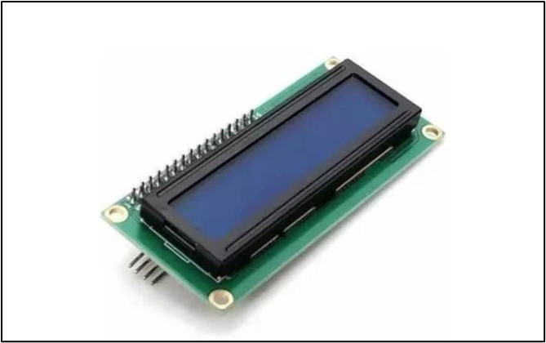

Source: ArduCore (2024).

* + 1. **Jumpers**

Jumpers are electrical wires that connect components. They come in different colors, thicknesses, and sizes and are mainly used in Protoboards and Arduinos (MONK, 2014).

In this application, we will use female-to-female jumpers, which are used to connect male pins and female-to-male jumpers, as we will be using the ESP-32 and the Protoboard, so this is the ideal type of jumper for the project. Below is a demonstration image of some types of jumpers:

Figure 5 – Jumpers

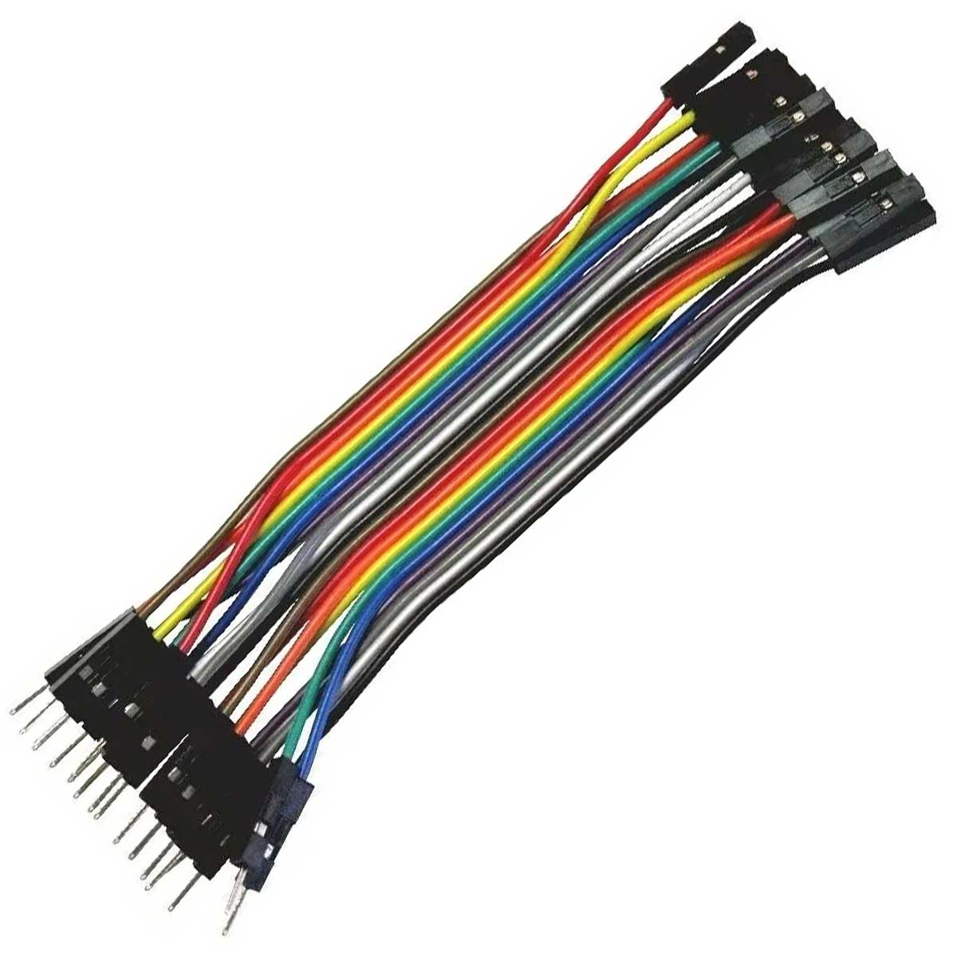

Source: Casa da Robótica (2024).

* + 1. **Passive Buzzer**

*Buzzers* are electromechanical devices that transform electrical energy into audible sound. They are used to emit alerts or melodies due to their low cost and ease of connection and operation (Alvarez, 2023).

The passive buzzer reproduces sound according to the shape of the electrical signal that triggers it, allowing it to imitate specific sounds, unlike the active buzzer, which only emits a whistle with its timbre (GUIMARÃES, 2017).

The passive buzzer will sound when the patient needs to take the medication prescribed by the doctor.

Figura 6 – Passive Buzzer

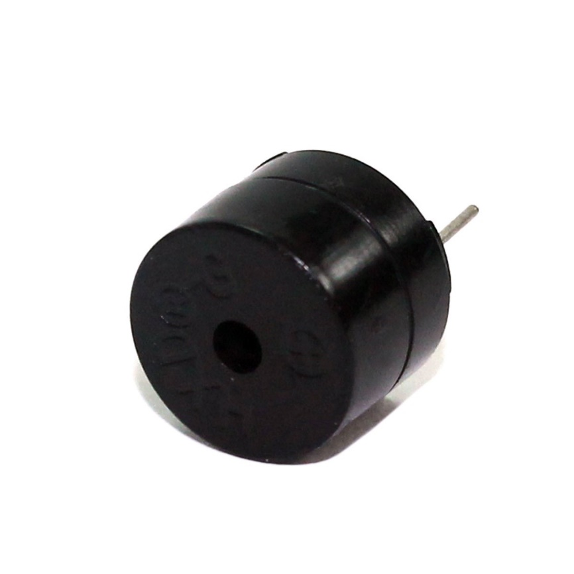

Source: Eletrônica Cuiabá, 2024.

* + 1. **Stepper Motor + Control Module (ULN2003Driver)**

According to Viana (2022), the stepper motor + control module (ULN2003Driver) is a direct current electric motor in which its shaft rotates in precise steps, moving by a fixed amount of degrees, being precise in angle, speed, position, and synchronism.

The motor is unipolar and has four windings called phases, so they are connected (ELETROGATE, 2018). This motor is generally used with the ULN2003 Driver, which allows the stepper motor to be easily controlled with a microcontroller (VIANA, 2022).

The component will manage the medication drop directly into the PillTrack box cup because its movement must be precise when it rotates. Thus, the compartment where the medication is stored will rotate 180º, releasing the pill drop one at a time. When the pill "dump" is complete, the system will automatically return to its original position.

The figure below shows an image of the Stepper Motor and Control Module (ULN2003Driver):

Figure 7 – Stepper Motor + Control Module (ULN2003Driver):

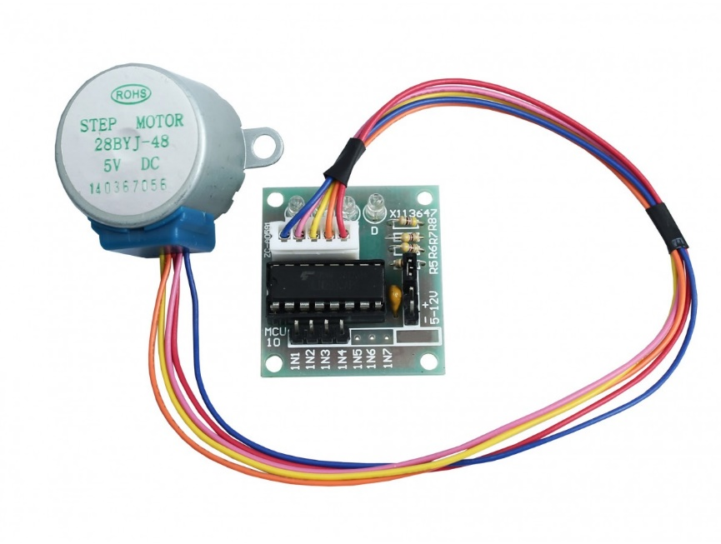

Source: Usinainfo (2024).

* + 1. **TCRT500 optical sensor**

The TCRT5000 is a reflective optical sensor that uses infrared reflection technology to detect the presence of objects (ELETROGATE, 2017). It consists of an infrared LED and an IR phototransistor, both attached to a plastic support. When an object approaches the sensor, the infrared light is reflected to the phototransistor, activating it (ARDUINO E CIA).

This sensor will be essential for detecting the withdrawal of the medicine through its infrared light because when it is removed, its reflection is interrupted, so the sensor will emit the absence of the medicine by sending a signal to the system, which will be interpreted by the application that the user has ingested the medication, thus being able to update the report so that the patient is following the medical prescriptions correctly.

You can now see an image of the TCRT5000 Optical Sensor:

Figure 8 – TCRT5000 Optical Sensor

Source: RoboCore (2024).

* + 1. **IoT**

The IoT is a network of devices and, generally, connected things that communicate through networks to perform specific tasks without requiring human interaction (SANTOS, 2018). The "IoT product" goes beyond the innovative product and the connected product, as it exploits the total capacity of the internet in physical products. Thus, it is effectively a system or, rather, a system of systems (SINCLAIR, 2018).

* + 1. **UML**

UML, or the Unified Modeling Language, is a visual language widely used to portray object-oriented software. It is versatile and applicable to various domains and has been adopted as an international standard in software engineering (GUEDES, 2018). It emerged from the union of several graphical object-oriented modeling languages that appeared in the 1980s and 1990s, so since its introduction in 1997, it has been a resource valued by many developers (FOWLER, 2005).

Modeling is linked to communication, and the UML provides essential tools for visualizing, specifying, building, and documenting artifacts of many complex software systems (BOOK, 2006). It is vital to model every system before starting its implementation because information systems tend to grow in size, complexity, and scope, so they are dynamic and constantly evolving. (GUEDES, 2018).

* + 1. **3D modeling**

3D modeling is considered a process of developing characters, objects, or scenarios in three dimensions, i.e., they have depth in addition to height and width (LOPES, 2023). Below is an example of 3D modeling and the prototype of a model created for 3D printing after being printed and painted.

Figure 9 – Example of 3D modeling

Source: From the authors (2024).

Figure 10 – Example of 3D printing

Source: From the authors (2024).

* + 1. **C++**

Developed by Bjarne Stroustrup at Bell Laboratories in the 1980s, C++ was created as a low-level programming language providing additional features to the C language (DEITEL; PAUL, 2015). Its versatile syntax supports object-oriented, procedural, generic, and functional programming (LOCAWEB). Below is an example of simple code programmed in C++:

* + 1. **React & React Native**

React is a JavaScript library that simplifies and streamlines the task of developing user interfaces (SILVA, 2021). React Native, based on React, is a JavaScript framework for creating cross-platform applications and offers an authentic user experience (ESCUDELARIO; PINHO, 2020).

With a declarative approach and code sharing, React Native speeds up development, enabling teams to create native applications efficiently (REACT NATIVE). Its operation depends on Node.js, which converts JavaScript code for platforms such as Android and iOS (DEVMEDIA).

* + 1. **Node.js & NPM**

Created in 2009, Node.js is a server-side JavaScript execution platform known for its asynchronous architecture and efficient I/O operations. It is ideal for developing APIs, real-time applications, and scalable backends (PEREIRA, 2014). Node.js uses a non-blocking thread model, optimizing processing by eliminating I/O stalls, which makes it possible to create scalable and efficient applications without long waits (DUARTE, 2020).

NPM is the Node.js package manager. It facilitates the management of dependencies, access to JavaScript libraries, and version control, simplifying project development and sharing (GADO, 2021).

* + 1. **Firebase**

According to Oracle (2023), Firebase is Google's mobile and web application development platform. It benefits from an end-to-end development environment, fast application creation, and scalable infrastructure. The Firebase console offers the most sophisticated environment for managing products, apps, and configurations at the Firebase project level (FIREBASE, 2023).

* + 1. **Firestore**

Cloud Firestore is a NoSQL database that allows data to be stored, synchronized, and consulted on mobile devices and the web. It also provides security rules for accessing the database without maintaining the server itself (FIREBASE).

In addition, it focuses on developing the application using a managed, serverless document database, making adjustments to meet any demand without maintenance windows or downtime. (GOOGLE CLOUD, 2024).

1. **Results and Discussions**

The system was created to help with the correct management of medication, especially for older adults who find it challenging to medicate themselves according to a doctor's prescription. Although its features have been well executed, there are doubts about implementing the device in a natural environment, especially when precision is required for patients' health.

As a result, tests become indispensable to point out any flaws in the system and ensure that patients can be sure that the PillTrack system is adequate for correctly managing medicines.

1. **Final considerations**

The PillTrack system aims to help patients, especially those who are elderly and find it challenging to manage their medication, medicate correctly, and improve treatment adherence. Through the app, it will be possible to improve communication between the patient and the doctor so that the professional can be sure that the patient is following their prescription correctly, ensuring precise treatment efficacy.

To ensure precision in time control and pill release, we will use the ESP-32 microcontroller, which will connect to the app via Bluetooth, and the Stepper Motor, which will release the pill at the correct time. The best choice for the application's development was the *UI* *software* framework React Native, which is available for both Android and iOS.

Although the system has not undergone security and reliability tests, PillTrack was created to improve its users' healthy lifestyles. We look forward to the project's development and to contributing to the lives of patients who need special help taking their medication correctly according to their doctor's prescription.

**References**

BOOCH, Grady; RUMBAUGH, James; JACOBSON, Ivan. **UML: User's Guide.** 2. ed. [S. l.]. GEN LTC, 2006.

DEITEL, Harvey; DEITEL, Paul. **C++ How to Program.** 5. ed. São Paulo: Pearson Prentice Hall, 2015.

DUARTE, Luiz. **Web programming with Node.js.** 6. ed. [S.l.]: LuizTools, 2017.

ELETRÔNICA ÔMEGA. **E-book Internet of Things for Beginners with ESP-32.** 1. ed. [S.l.]: Arduino Omega, 2021. Digital book.

ESCUDELARIO, Bruna; PINHO, Diego. **React Native: Mobile Application Development with React.** [S.l.]: Casa do Código, 2020.

FOWLER, Martin. **UML Essentials: A Brief Guide to the Standard Language.** [S.l.]: [s.n.].

GUEDES, G. T. A. **UML 2 -** A **Practical Approach.** [S.l.]: Novatec Editora, 2018.

MONK, Simon**.** **30 Projects with Arduino.** 2. ed. Porto Alegre: Artmed, 2014.

PEREIRA, Caio Ribeiro. **Real-Time Web Applications with Node.js.** [S.l.]: Casa do Código, 2014.

SILVA, Maurício Samy. **React - Learn by Doing:** **Develop Real Web Applications Using the React Library and Its Helper Modules.** 1. ed. São Paulo: Novatec, 2021.

SANTOS, S. **Introduction to IoT:** **Unraveling the Internet of Things.** North Charleston, SC, USA: Createspace Independent Publishing Platform, 2018.

PEREIRA, Marcelo Robson Sousa. **The application of the ESP32 microcontroller in teaching: measuring positions as a function of time using the VL53L0X sensor associated with ESP32**. Supervisor: Victor Montero Del Águila. 2020. 24 f. Course Conclusion Paper (Specialization) - Postgraduate Department, Federal University of Amapá, Macapá, 2020. Available at: <http://repositorio.unifap.br:80/jspui/handle/123456789/898>. Accessed on: May 20, 2024.

PUHLMANN, Henrique Frank W. **LCD display module**. [S.l.]: [s.n.], 2015.

ALBERTIN, A. L.; ALBERTIN, R. M. DE M. **The internet of things will go far beyond things.** GV-executivo, v. 16, n. 2, p. 12-17, 2017.

MASSOLA, S. C.; PINTO, G. S. **Use of the internet of things (IoT) in favor of health.** Revista Interface Tecnológica, v. 15, n. 2, p. 124-137, 2018.

KATZ, Marcelo; FEITOSA, Gustavo Freitas; PINTO, Ibraim Masciarelli F.; FELIX, Marcelo de Maria; BORTOLOTTO, Luiz Aparecido. **Using technology to engage patients and optimize therapeutic adherence.** Revista da Sociedade de Cardiologia do Estado de São Paulo, [S.l.], v. 30, n. 3, p. 352-357, October 20, 2020. Available at: [07_revistasocesp_v30_03.pdf](https://bvsalud.org/). Accessed on: March 10, 2024.

ALVAREZ, Danilo. **Buzzer with ESP32 - Basic ESP32 course.** Silicon Life Portal, November 6, 2023. Available at: <https://portal.vidadesilicio.com.br/buzzer-com-esp32-curso-esp32-basico>. Accessed on: May 23, 2024.

CAMPINAS, U. **Understand the impact and importance of medical monitoring.** Available at: <https://www.unimedcampinas.com.br/blog/viver-com-saude/entenda-o-impacto-e-a-importancia-do-acompanhamento-medico>. Accessed on: March 26, 2024.

ELETROGATE. **28BY-48 Stepper Motor Guide = ULN3003 Driver**. Elotrogate, July 23, 2018. Available at: <https://blog.eletrogate.com/guia-completo-do-motor-de-passo-28byj-48-driver-uln2003/>. Accessed on: October 19, 2024.

EUROFARMA. **The importance of taking medicine on time.** 2018. Available at: <https://eurofarma.com.br/artigos/a-importancia-de-tomar-remedio-na-hora-certa-inclusive-para-idosos>. Accessed on: March 12, 2024.

FERREIRA, A. P. C.; CAMPOS, E. M. P. **The Health Team in the Face of Patients Not Adhering to Treatment.** Psicologia: Ciência e Profissão, v. 43, p. e244855, February 20, 2023. Available at: <https://www.scielo.br/j/pcp/a/TQtxVL3fdgXTYvhyRfXFvJp/>. Accessed on: March 26, 2024.

FIREBASE. **Make your app the best it can be with Firebase and generative AI.** [S.l.]. Available at: <https://firebase.google.com/?hl=pt-br>. Accessed on: May 19, 2024.

FIREBASE. **Cloud Firestore | Store and synchronize app data on a global scale.** [S.l.]. Available at: <https://firebase.google.com/products/firestore?hl=pt-br>. Accessed on: June 18, 2024.

GADO, Wesley. **What is NPM and how to use a library installed by it.** TreinaWeb Blog. Available at: <https://www.treinaweb.com.br/blog/o-que-e-npm-e-como-usar-uma-biblioteca-instalada-por-ele/>. Accessed on: May 15, 2024.

GOOGLE CLOUD. **Firebase.** [S.l.]. Available at: <https://cloud.google.com/firestore#benefits>. Accessed on: June 18, 2024.

GUIMARÃES, Fábio. **Buzzer - How to use it with Arduino.** Mundo Projetado, August 11, 2017. Available at: <https://mundoprojetado.com.br/buzzer-como-usar-com-o-arduino>. Accessed on: May 23, 2024.

HIGA, P.; MARQUES, A. **What is LCD?** **Learn about the types and advantages of this technology.** Tecnoblog. Available at: <https://tecnoblog.net/responde/o-que-e-lcd/>. Accessed on: May 21, 2024.

LOCAWEB. **C++: a guide to the programming language.** Available at: <https://www.locaweb.com.br/blog/temas/codigo-aberto/c-plus-plus/>. Accessed on: May 26, 2024.

LOPES, Michele. **3D modeling: what it is and how it works.** Ebac Online, September 29, 2023. Available at: <https://ebaconline.com.br/blog/modelagem-3d-o-que-e-e-como-funciona/>. Accessed on: May 26, 2024.

MAKIYAMA, M. **ESP32 board: What it is, what it's for and how to use it!** Available at: <https://victorvision.com.br/blog/placa-esp32>. Accessed on: May 20, 2024.

PIXEL DIAGNOSTICS. **The importance of communication between patient and health professional.** Available at: <https://pixeldiagnostico.com.br/blog/post/2020-10-10-a-importancia-da-comunicacao-entre-o-paciente-e-o-profissional-de-saude>. Accessed on: March 26, 2024.

PUHLMANN, H. F. W. **LCD Display Module**. Available at: <https://embarcados.com.br/modulo-de-display-lcd>. Accessed on: June 25, 2024.

REACT NATIVE. **React Native - A framework for building native apps using React.** Available at: <https://reactnative.dev/>. Accessed on: May 3, 2024.

ARDUINO AND CIA. **TCRT5000 reflective optical sensor with Arduino**. Available at: <https://www.arduinoecia.com.br/sensor-optico-reflexivo-tcrt5000-arduino/>. Accessed on: June 18, 2024.

VIANA, Carol Correia. **How to drive a stepper motor with ULN2003 Driver and Arduino**.Robotics Blog, June 30, 2022. Available at: <https://www.blogdarobotica.com/2022/06/30/como-acionar-motor-de-passo-com-driver-uln2003-e-arduino/>. Accessed on October 2, 2024.

The contents expressed in the work, as well as the copyright of figures and data, as well as its spelling and standards revision, are the sole responsibility of the authors.

The authors of the paper declare that during the preparation of the manuscript they used Artificial Intelligence (AI) tools/services to translate the texts into Spanish and English.